**Cognitive Computing**

**What is Cognitive Computing?**

**It is the use of computerized models that simulates human thought process in complex situations where answers might be ambiguous and uncertain**

**OR**

**it is an attempt to have computers mimic the way the human brain works.**

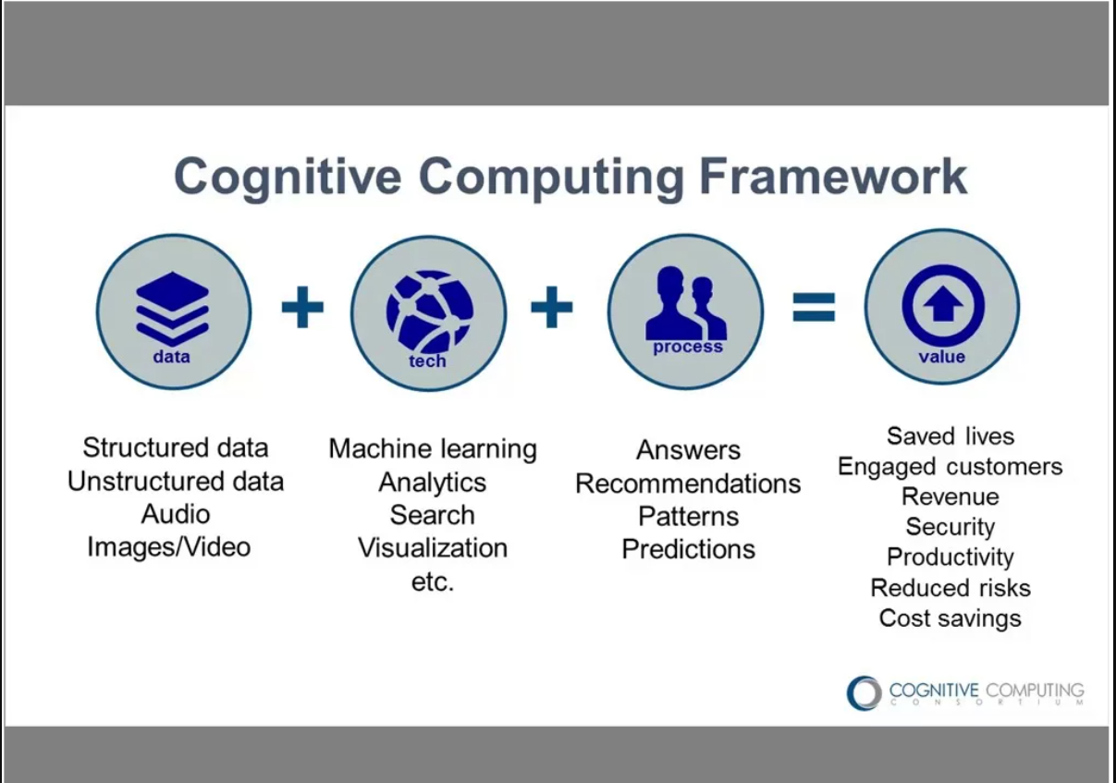

**Cognitive computing uses artificial intelligence (**[**AI**](https://www.techtarget.com/searchenterpriseai/definition/AI-Artificial-Intelligence)**) and other underlying technologies, including the following:**

* [**Expert systems**](https://www.techtarget.com/searchenterpriseai/definition/expert-system)**.**
* [**Neural networks**](https://www.techtarget.com/searchenterpriseai/definition/neural-network)**.**
* **Machine learning.**
* **Deep learning.**
* **Natural language processing (**[**NLP**](https://www.techtarget.com/searchenterpriseai/definition/natural-language-processing-NLP)**).**
* **Speech recognition.**
* [**Object recognition**](https://www.techtarget.com/whatis/definition/object-recognition)**.**
* **Robotics.**

**It uses these processes in conjunction with self-learning algorithms, data analysis and pattern recognition to teach computing systems.**

**It is particularly used in fields of healthcare, banking, finance and retail.**

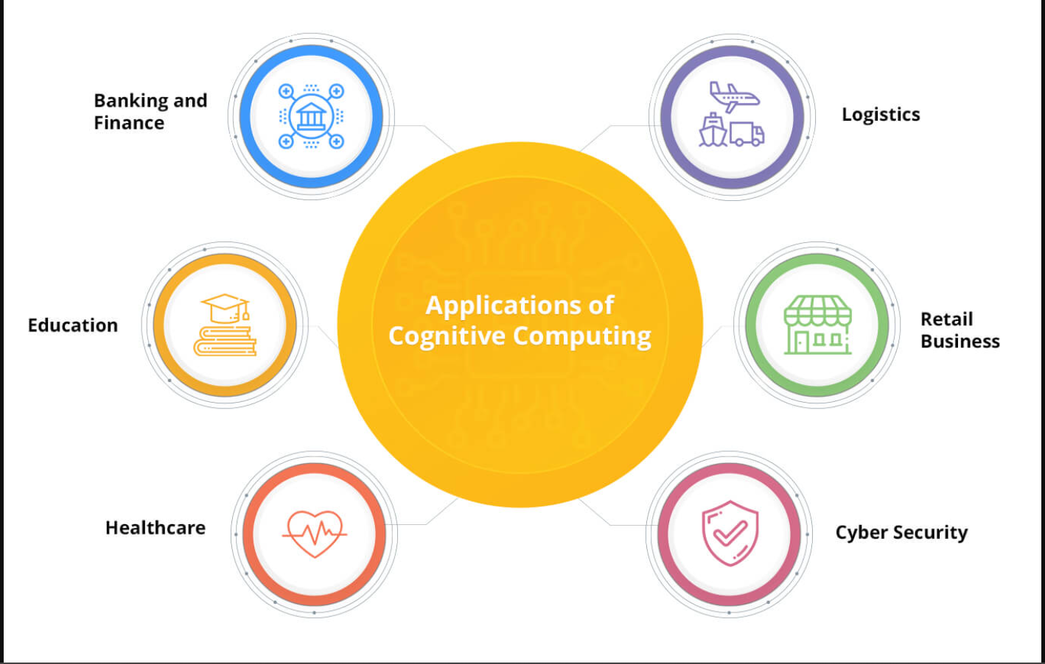

**How Cognitive Computing Works**

**Systems used in the cognitive sciences combine data from various sources while weighing context and conflicting evidence to suggest the best possible answers. To achieve this, cognitive systems include self-learning technologies that use**[**data mining**](https://www.techtarget.com/searchbusinessanalytics/definition/data-mining)**, pattern recognition and NLP to mimic human intelligence.**

**To achieve those capabilities, cognitive computing systems must have the following attributes:**

* **Adaptive**
* **Interactive**
* **Iterative and stateful**
* **Contextual**

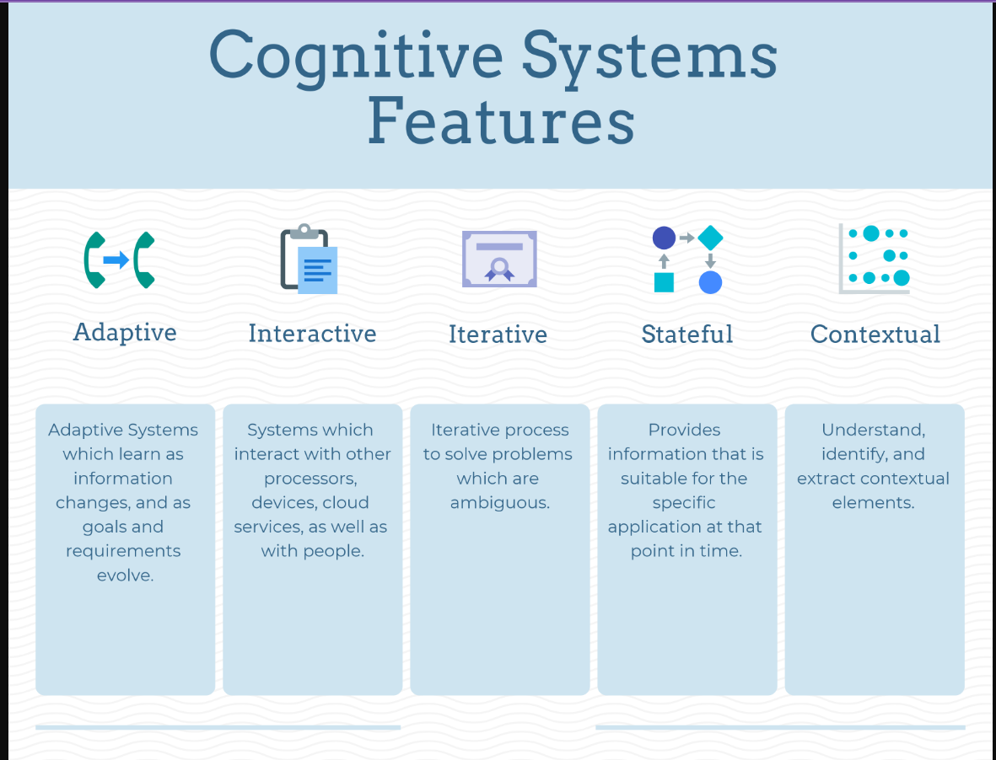

**Advantages of Cognitive Computing**

* **Analytical Accuracy**
* **Business Process Efficiency**
* **Customer Interaction and Experience**
* **Employee Productivity and Service Quality**
* **Troubleshooting and Error Detection**

**Disadvantages of Cognitive Computing**

* **Security Challenges**
* **Long Development Cycle Length**
* **Slow Adoption**
* **Negative Environmental Impact**

**How Cognitive Computing differs from A.I.**

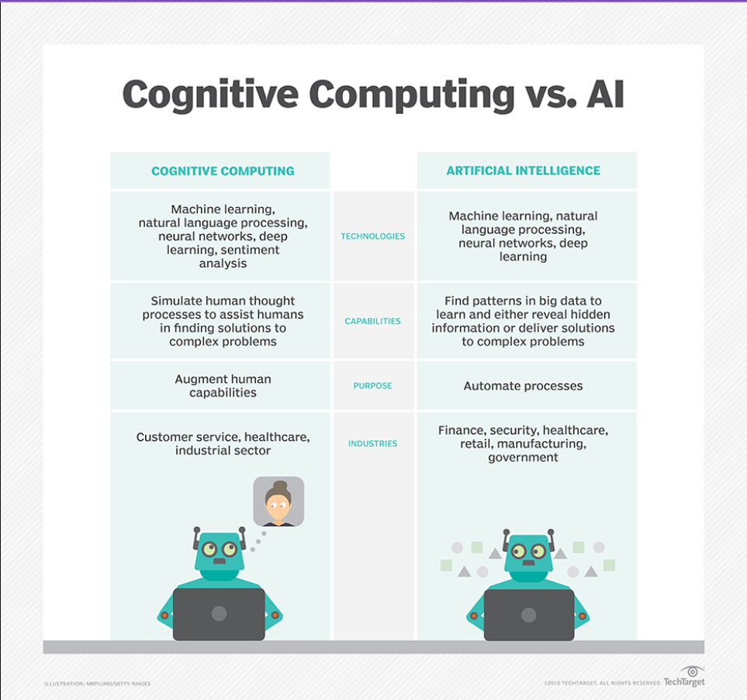

**Source: TechTarget**

**[**[**Kinza Yasar,**](https://www.techtarget.com/contributor/Kinza-Yasar)Technical Writer

[**Alexander S. Gillis,**](https://www.techtarget.com/contributor/Alexander-S-Gillis)Technical Writer and Editor

[**Bridget Botelho,**](https://www.techtarget.com/contributor/Bridget-Botelho)Editorial Director, News]